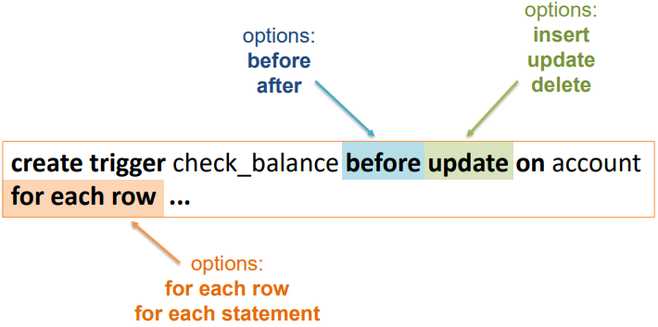**Question 5.**

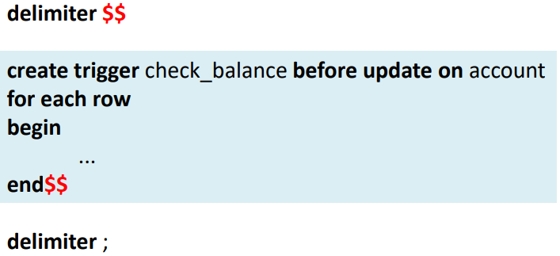

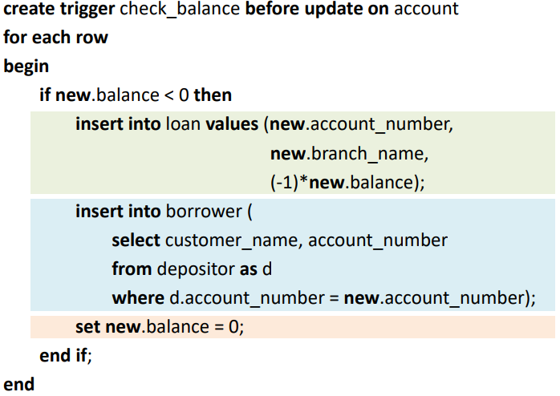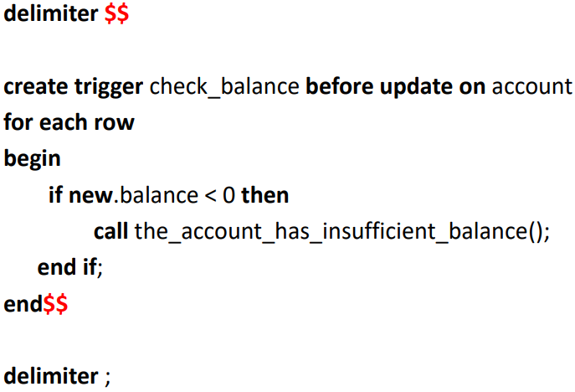EXAMPLE:

To invalidate an operation we call a non-existing function.

i)

delimiter $$

CREATE TRIGGER ensure_doctor BEFORE INSERT ON Study FOR EACH ROW

begin

if  (select distinct number from Request where doctor_id =new.doctor_id and new.request_number = number) then

call error_doctor_made_request();

end if;

end$$

delimiter ;

/*Insert valid element*/

insert into Study values( '93', 'ECG', '2016-04-23', '69', '0999', 'Medtronic');

delete from Study where doctor_id = 69 and serial_number = 0999;

/*Insert invalid (same doctor)*/

insert into Study values( '124', 'ECG', '2016-04-23', '13', '0999', 'Medtronic');

delete from Study where doctor_id = 13 and serial_number = 0999;

drop trigger ensure_doctor;

ii)

delimiter $$

CREATE TRIGGER device_overlap BEFORE INSERT ON Wears FOR EACH ROW

begin

if new.start < (SELECT endt FROM Wears WHERE new.patient = patient) then

if new.endt > (SELECT start FROM Wears WHERE new.patient = patient) then

signal sqlstate '45000' set message_text='Overlapping Periods';

call error_message();

end if;

end if;

end$$

delimiter ;

/*Insert valid statement*/

INSERT INTO Period VALUES('2018-09-12 18:58:39', '2018-09-21 18:58:39');

INSERT INTO Wears VALUES('2018-09-12 18:58:39', '2018-09-21 18:58:39', '35534', '246d3', 'IPOZ');

DELETE FROM Wears WHERE start = '2018-09-12 18:58:39';

DELETE FROM Period WHERE start = '2018-09-12 18:58:39';

/*Insert invalid statement*/

/*start in end out*/

INSERT INTO Period VALUES('2017-09-17 18:58:39', '2017-09-23 18:58:39');

INSERT INTO Wears VALUES('2017-09-17 18:58:39', '2017-09-23 18:58:39', '35534', '246d3', 'IPOZ');

DELETE FROM Wears WHERE start = '2017-09-17 18:58:39' AND endt = '2017-09-23 18:58:39';

DELETE FROM Period WHERE start = '2017-09-17 18:58:39' AND endt = '2017-09-23 18:58:39';

/*start out end in*/

INSERT INTO Period VALUES('2017-09-10 18:58:39', '2017-09-18 18:58:39');

INSERT INTO Wears VALUES('2017-09-10 18:58:39', '2017-09-18 18:58:39', '35534', '246d3', 'IPOZ');

DELETE FROM Wears WHERE start = '2017-09-10 18:58:39' AND endt = '2017-09-18 18:58:39';

DELETE FROM Period WHERE start = '2017-09-10 18:58:39' AND endt = '2017-09-18 18:58:39';

/*start in end in*/

INSERT INTO Period VALUES('2017-09-13 18:58:39', '2017-09-20 18:58:39');

INSERT INTO Wears VALUES('2017-09-13 18:58:39', '2017-09-20 18:58:39', '35534', '246d3', 'IPOZ');

DELETE FROM Wears WHERE start = '2017-09-13 18:58:39' AND endt = '2017-09-20 18:58:39';

DELETE FROM Period WHERE start = '2017-09-13 18:58:39' AND endt = '2017-09-20 18:58:39';

/* start out end out*/

INSERT INTO Period VALUES('2017-08-12 18:58:39', '2017-10-21 18:58:39');

INSERT INTO Wears VALUES('2017-08-12 18:58:39', '2017-10-21 18:58:39', '35534', '246d3', 'IPOZ');

DELETE FROM Wears WHERE start = '2017-08-12 18:58:39' AND endt = '2017-10-21 18:58:39';

DELETE FROM Period WHERE start = '2017-08-12 18:58:39' AND endt = '2017-10-21 18:58:39';

drop trigger device_overlap;

/*When the error ocurrs we must reset these parameters manualy:

drop trigger device_overlap;

DELETE FROM Period WHERE start = '2017-09-17 18:58:39' AND endt = '2017-09-23 18:58:39';*/